Food Prices, Yields, and State Fragility

David Price 6/12/17

UCSD School of Global Policy

**Introduction & Motivation:**

Volatility in food prices and food supply shocks can have serious implications for both individual’s access to needed food and nutrition as well as state stability in politically insecure regions. Food price swings and supply shocks can occur due to various reasons and are an intrinsic challenge present in global food markets. As a result of the 2008 financial crisis, for example, world prices of cereals such as maize, wheat, and rice experienced a significant and sudden rise[1]. This rise in global food prices occurred due to a variety of reasons that include supply and demand side factors and poor food related policies. For developing countries, the rise in prices impacted poor citizen’s ability to access and afford food. Secondly, beyond access issues, the sudden rise in prices caused food related riots that occurred throughout the world including in Sub Saharan Africa and developing countries in Asia[2]. Furthermore, the food price shock may have even impacted some of the world’s current civil wars. Considering the significant link between food security and political stability, it is likely that some of the world’s most severe civil conflicts have been exacerbated by inadequate food access and price volatility. Accordingly, the principle question explored in this analysis is whether there is a significant correlation between cereal yields, nominal food prices, and state stability in the Middle East. Specifically, this analysis looks at the correlation between state stability decline in the Middle East and changes in food prices and cereal yields. The primary countries of interest in this analysis are Yemen, Iraq, Syria, and Egypt. All four countries have experienced significant increases in state fragility and violence in recent years, some of which may be linked to food security challenges.

Before exploring the link between food accessibility, price volatility, and state stability it is important to discuss the terms and mechanisms which this analysis explores. Food access refers to an individual’s ability to acquire food and nutrition required to live a productive life. As discussed by Amartya Sen, serious food access issues, such as famines, can occur as a result of two, broad, causes: food availability declines and entitlement declines[3]. Food availability declines (FADs) refer to declines in the supply or availability of food in a given region at a given time. In other words, a lack in the supply of food. Sen discusses that FADS are often not the principle cause of inadequate access to food. Instead, Sen notes that entitlement issues are frequently the true cause of famines and serious food security issues. Entitlements are a person’s ability to have a right to food or another “commodity bundle.” Sen discusses that a person’s “entitlement set,” or set of tradable items and skills, impacts their ability to procure food. One’s entitlement set can work through several mechanisms including growing food, buying food, working for food, or being given food[4]. Sen coins this lack of adequate ability to trade either labor or money for food as the “exchange entitlement decline.”

Although Sen specifically relates both FADs and exchange entitlement declines to famines, these two mechanisms are also correlated with increases in civil conflict and state fragility. Relatedly, an important mechanism working through FADs and entitlement declines are food price shocks. Food price shocks can occur as a result of supply and demand shocks, and policy choices pursued by state governments. Two relevant examples of supply shocks are poor harvests and rises in the price of key inputs. Poor harvests of important cereals, caused by blights or droughts, impact food prices through an acute reduction in supply. As for input shocks, the price of agricultural inputs and other commodities impacts the price of food through an increase in the marginal cost of production. For example, in the early 2000s, a large increase in the price of oil caused the price of soybeans and wheat to increase by 30%-40%[5]. Demand shocks, on the other hand, refer to mechanisms that impact prices through the demand for a given commodity. This kind of shock is illustrated in the example where the demand for biofuels causes an increase in food prices due to the fact that certain staple foods are also key inputs to biofuel production[6]. The increase in demand for biofuel causes an increase in production and, through the laws of supply and demand, increases the price of biofuel inputs such as corn. Finally, policy choices pursued by governments such as export bans, food stock piles, and tariffs can also directly and indirectly impact food prices. One example are export bans, which are often pursued by governments to keep food from leaving local markets[7]. Although export bans are pursued with good intentions, they do not always result in good outcomes. In Africa, for example, export bans have increased food prices and led many rural poor to be more rather than less food insecure[8].

The following analysis explores the two identified factors, food availability and price volatility, in the context of the state fragility of four countries in the Middle East: Egypt, Syria, Yemen, and Iraq. The state fragility level of these four countries is analyzed using the State Fragility Index dataset from the Center for Systemic Peace[9]. The dataset I construct to complete this analysis is comprised of several index measures of state fragility and government effectiveness as well as outside data from the World Bank and Food and Agriculture Organization of the United Nations (FAO). More details of this unique dataset are provided in the **Data Construction** section of this paper. The four countries focused on in this paper are selected over other regions of the world due to both the high degree of conflict currently present in these countries and because of the volume of past research that has been completed on the topic. In the following analysis, I discuss some of the relevant and recent literature on the relationship between food security and civil conflict in the middle east and also perform a brief data exploration exercise and statistical analysis. To perform the analysis, I use a fixed effects estimator, controlling for year and country fixed effects, to assess how changes in nominal prices and cereal yields correlate with decreases in state stability. The following sections are comprised of a literature review, an explanation on the dataset construction, an overview of the methods and specifications, an explanation of the results, and a discussion on threats to validity and conclusions from the analysis.

**Literature Review:**

There have been several recent papers that have examined the relationship between food security and civil conflict. These studies have examined different regions of the world and have used various econometric and data analytic methods to explore how food insecurity drives domestic conflict and state instability. For example, Berazneva and Lee measure the part that commodity price swings played in the numerous African food riots that occurred in 2007 and 2008. In their analysis, the authors use a cross country logit model with a discrete binary outcome variable representing whether or not a given country had a food riot. In terms of their results, the author’s first identify that the level of poverty in a given country is an important indicator of whether a country had a food riot or not[10]. Additionally, the authors find that the quality of governance and the orientation of policies to be aimed towards helping the poor also were predictive in explaining which countries experienced food riots. Ultimately, Berazneva and Lee explain that food price shocks and the inevitable impact that climate change will have on agricultural productivity has serious implications for political stability in poor countries moving into the future.

Like Berazneva and Lee, Natalini et al. preform a quantitative assessment of the relationship between food prices and state instability using a cross country panel dataset[11]. Much like the prior paper discussed here, Natalini et al. perform a propensity to food riots analysis using a logit model and several indices of political stability and food prices. The authors set out to explain incidence of conflict and food riots in various regions and also aim to assess the efficacy of ten different political stability indices in explaining the incidence of food riots. In their analysis, the authors find that a country’s self-sufficiency in food production does not correlate with the occurrence of food riots, but that political stability is a key indicator of whether there will be a food riot. Additionally, the authors use the FAO food CPI to identify if there is a threshold of food price level at which there is a significantly higher likelihood of food related riots. In this component of the analysis, the authors find that when prices are above 148 on the food CPI scale, there is a significant increase in the number and likelihood of food riots. The analysis completed by Natalini et al. generally supports the conclusions found by Berazneva and Lee in that both sets of authors find that both food price and political stability are predictive in explaining when there may be food riots.

Although Berzneva and Lee and Natalini et al. find that food price shocks impact state stability, other research has taken it one step further and examined the role that climatic changes and natural resource management plays in driving civil conflict. Femia, Werrel, and Sternberg, for example, explore the impact that climate conditions and resource management had in causing the uprisings in Egypt and Syria in 2011[12]. The authors pursue a qualitative investigation of the food insecurities, water resources, and climatic conditions prior to the Arab uprisings and compare their findings with the conditions indicated by two indices that are commonly used to measure state stability and climate vulnerability. Specifically, the authors compare their findings with trends shown in the Failed State Index (FSI) and the climate vulnerability index (ND-GAIN). Generally, the authors find that the FSI and ND-GAIN indices did not capture the impact that mismanagement of crop lands and a regional drought had on food production and political tension. For example, prior to the uprising in 2011, Syria had an increasing ND-GAIN score, which indicates that the country was becoming more climatically prepared and robust to exogenous shocks. As noted, however, the beginning of the civil war that has persisted up to today shows that Syria was not, in fact, as stable and food secure. Similarly, for Egypt the authors identify that a sharp increase in the global price of wheat in 2010 may have played a role in the uprisings that occurred there. More specifically, Egypt is one of the world’s largest importers of wheat and, thus, was particularly susceptible to global price swings and economic shocks. Femia, Werrel, and Sternberg’s research not only shows the need for improvement in global measurement indices, but also illustrates the role that food price shocks and climatic changes plays in causing decreases in political stability.

All three papers discussed here identify that food prices and access are predictive of when and where conflict may occur. Furthermore, all three sets of authors identify that the available indices used to measure political stability fall short of fully taking into account the importance of food prices and productivity, prior to the start of significant armed conflict. Like the other papers discussed here, my analysis cannot speak to a clean causal relationship between food prices, cereal yields, and state stability decline. More specifically, changes in prices and yields are not applied exogenously and are not only related to one another, but also are related to the outcome variable of state fragility. Thus, endogeneity plagues making a clean causal statement of how food prices and productivity declines drive rises in conflict. Given these challenges, the proceeding analysis aims to discuss and point out significant trends and correlations in the data between state stability, food prices, and cereal yields.

**Data Construction:**

To perform the data analysis exercise presented here, I merge three separate sets of data. For the outcome variable, the state fragility index, I use data from systemicpeace.org compiled at George Mason University. This dataset contains several variables that categorically measure the stability of a given country in a given year. Thus, the data obtained from systemicpeace.org is unique at the country and year level. As defined by the compilers of the dataset, state fragility is defined as the following: “A state may remain in a condition of fragile instability if it lacks effectiveness or legitimacy in a number of dimensions; however, a state is likely to fail, or to already be a failed state, if it has lost both[13].” The state fragility index score is comprised of eight sub scores that include the effectiveness and legitimacy score for the political, social, economic, and security categories. The overall score runs from 0 to 24 where 24 represents the most unstable countries and 0 represents the most stable countries. For easing interpretation, one can break the state fragility index into four categories where 0 to 5 represents low fragility, 6 to 12 represents medium fragility, 13 to 18 represents high fragility, and 19 to 24 represents very high fragility. It is important to note that although the index aids in categorizing the overall fragility of countries across time, the movement along the number line in this index is only ordinal and does not represent cardinal changes as countries move up or down in the index. Thus, the outcome variable should be considered a categorical measure.

In terms of the independent covariates used in the analysis, I use data from the World Bank and the Food and Agriculture Organization of the United Nations (FAO). Firstly, the food CPI variable comes from the FAO database and catalogues annual changes in the CPI of food for world countries from 2000 to 2015. As described by the compilers of the FAO CPI dataset, the food CPI “consists of the average of five commodity group price indices, weighted with the average export shares of each of the groups[14].” To operationalize these data, I use the logarithmic form of the food CPI variable in all econometric analysis performed in this paper. The log form accounts for the long right tail of the distribution of the food CPI variable and also eases the interpretation of the marginal effect of changes in food CPI on the state fragility index. To obtain these data, I downloaded the relevant food CPI from the FAO website and merged it with the World Bank and State Fragility data. The principle variable obtained from the world bank database is the measurement of country level annual cereal yields. This variable specifically measures the annual yields of cereals, in kilograms per hectare terms, for the following cereals: wheat, rice, maize, barley, oats, rye, millet, sorghum, buckwheat, and mixed grains[15]. Although the cereal yields variable is normalized by the yields per hectare for each country, I go a step further to normalize this measurement of productivity by the total population count for each country in each year. Thus, this variable now measures the kilograms of cereals per hectare per person produced in each year by each country. Additionally, I use the logarithmic form of this variable as well to account for the log normal distribution of the data.

To operationalize the full dataset, I complete three sets of merges in STATA using the unique country and year for the FAO data, state fragility data, and the World Bank data. Due to some missing data, there are 117 unique countries in the dataset as well as 15 years. Although there are many years of state fragility and world bank data available, the FAO website only has 15 years of food price data. Thus, this dataset includes years 2000 through 2015 rather than earlier years. Accordingly, there should be 1,755 unique observations in the dataset, consisting of the 15 years and 117 countries. As a result of missing data, there are 1,749 unique observations at the country year level.

*Figure (1): Trend of World Yields & Food CPI Over Time*

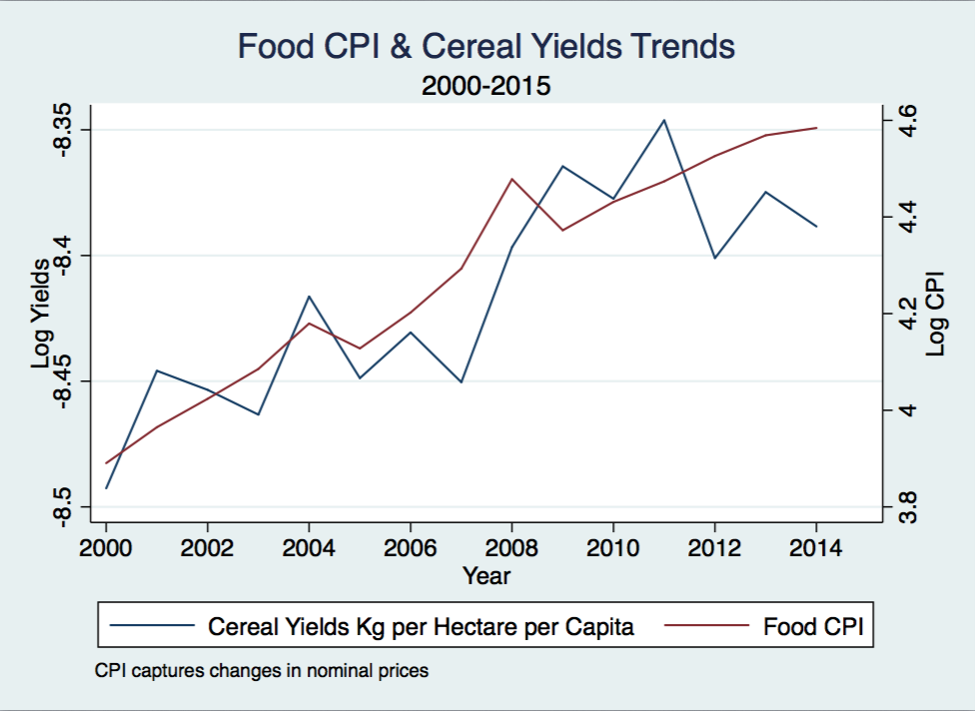

In terms of basic trends in the data, overall world cereal yields and food CPI both increase throughout the sample period used in the analysis. These two trends are shown below in *Figure (1).* Because the food CPI captures the movement of nominal prices, the trend of CPI increases steadily over time. Having said this, the 2008 financial crisis is visible in the graph with a larger than average spike in prices. As for yields, the general trend shows increases in yields, but also shows various booms and busts throughout the sample period. Overall, the two trends indicate fairly steady nominal price growth and productivity growth. The trend of these two factors in the four countries of interest, however, tells a different story. *Figure (2)* and *Figure (3)* show the trend of food CPI and cereal yields per kg per hectare per capita for Egypt, Syria, Iraq, and Yemen. As shown, the variation in nominal prices is generally higher in these four countries than the world average. For example, at the beginning of the war in Syria in 2010, nominal prices show a significant price jump until the end of the sample period. The results of the visualization of trends indicates that productivity and prices has had more drastic variation in these four countries than world movement of these factors.

*Figures (2) & (3): Select Countries Trend of Food CPI & Cereal Yields*

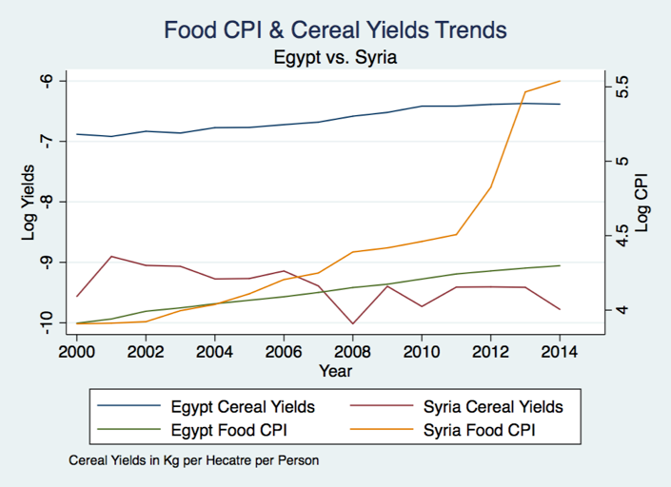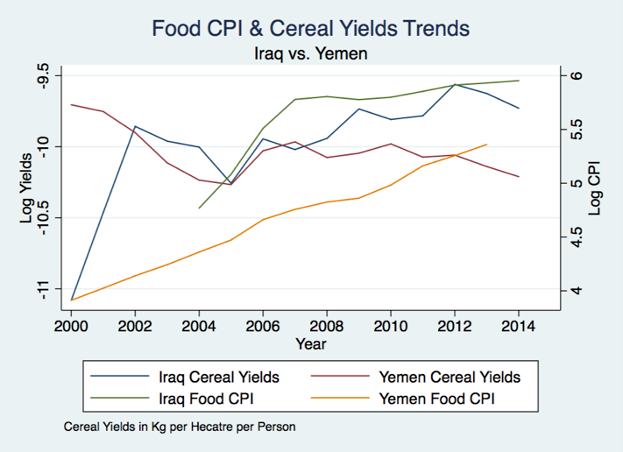

A similar story is told when examining trends in the dependent variable of the state fragility index. Overall, state fragility across the world has been declining monotonically throughout the sample period. *Figure (4)*, however, shows that the trend of state fragility for the four countries of interest in this analysis has remained poor or increased over time. For example, in 2010 both Syria and Yemen have significant increases in the state fragility index scores. Egypt shows improvement in state stability after 2004 and Iraq shows very high levels of state fragility across the entire sample period.

*Figure (4): State Fragility for Select Countries Over Time*

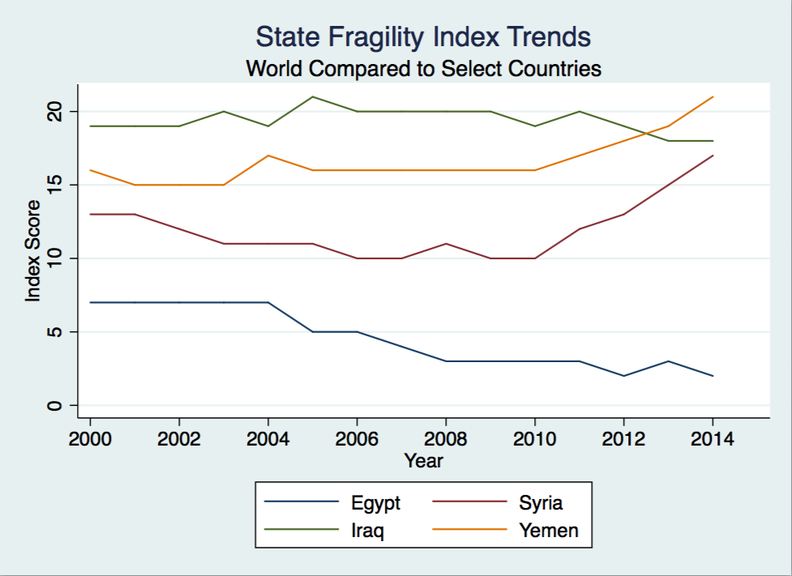

**Methodology & Specifications:**

To further explore the trends shown in the previous section, I use two fixed effects models controlling for country and year fixed effects. The first model examines the impact of changes in the food CPI on changes in the state fragility index. Accordingly, the dependent variable in this model is the state fragility index and the independent variable is the log of the food CPI. To pullout the individual impact that this treatment variable (food CPI) has on state fragility in Syria, Yemen, Egypt, and Iraq, I interact the food CPI variable with dummy variables representing each of the four countries. Therefore, this model includes the log food CPI, an un-interacted dummy variable for each of the four countries, and the interaction of food CPI with each country. This way I can observe both the impact of changes in food prices on state fragility as well as the impact of changes in prices for each of the countries separately. Other controls in this model include the year fixed effects and country fixed effects. The second model I examine is a country year fixed effects estimator testing the impact of changes in cereal yields on changes in the state fragility index. In this model, I have the same outcome variable and use the same interaction term structure as the first model where I interact dummy variables for each of the four countries with the log cereal yields variable. This model includes the same controls as the first model.

For both models, I use the fixed effects estimator to examine within changes of state fragility, rather than looking at changes in levels for several reasons. The year fixed effects account for time variant changes that impact all countries in the sample and, thus, control for any movement of business cycles over the sample period as well as economic shocks that may have impacted all countries in the sample. The country fixed effects control for time invariant differences between countries and, therefore, control for baseline differences between countries in the sample. It is worth pointing out that I use a reduced form test of the two treatments rather than including additional covariates and mechanism variables. Including mechanisms and attempting to measure a “net” treatment effect causes additional concerns about endogeneity and, ultimately, makes it challenging to assess the marginal effect of changes in the treatment variable on the outcome of interest. Also, there are two other points of importance. Since I interact the individual country dummies with the treatment effect, the country fixed effects for Egypt, Yemen, Iraq, and Syria are collinear with the country specific dummy variables. Thus, the country fixed effects account for the other 113 countries only. I also use clustered standard errors at the country level to account for autocorrelation and to adjust the degrees of freedom of the analysis for more accurate standard error estimation. The following two equations show the two econometric models used in this analysis:

*Estimating Equations:*

+ + + + +

+ + + + +

As shown above, subscript *(i)* represents the specific country, subscript *(t)* represents the given period, and *SFI* represents the outcome variable of interest. Each beta coefficient ( $β_{\#})$ represents the marginal effect of each covariate and interaction. Alpha ( $α)$ denotes the country specific fixed effects and theta $(θ)$ denotes the year fixed effects. Epsilon $(ε$) represents the error term in each model.

There are several short comings of the model and econometric analysis that are important to point out before diving into the results. Firstly, the food CPI and cereal yield changes are, by no means, exogenous to changes in state fragility. The relationship is endogenous and, therefore, changes in state fragility could drive changes in cereal yields and prices as well as the relationship moving in the opposite direction. Moreover, yields and prices are also related to one another and exhibit an equally endogenous relationship as the relationship between the treatment variables and state fragility. Needless to say, this analysis cannot speak to the causal relationship exhibited here. Having said this, correlations in the data are still informative and instructive as to the relationships between the factors tested in this analysis. Secondly, the analysis is somewhat coarse in that it does not contain subnational yield, price, and fragility information nor does it have changes in units of time that are less than annual. Therefore, there could be heterogeneity that is not measurable due to the fact that it may occur at spatial or temporal units that are more granular than the dataset used here. Finally, the overall trend of inflation in the CPI data, due to the fact that the CPI is comprised of nominal pries, may consequently impact the estimation presented here. Generally, it is better to use real prices than nominal prices because regression estimates are more accurate under a stationary process rather than a process that is not stationary (i.e. continual inflation). I was unable to obtain real food price data and, therefore, the nominal CPI is satisfactory.

**Results:**

*Table (1)* shows the regression results of the first model, testing the impact of changes in food price on changes in state fragility. The first column shows a cross sectional comparison of the model, column 2 shows the model with only year fixed effects, and column 3 shows the model with year and country fixed effects. Accordingly, the results of the first two iterations of the model indicate that increases in the nominal price of food has a statistically significant relationship with increases in state fragility at the 95% and 90% confidence level. This relationship becomes insignificant in the full model, which suggests that increases in nominal food prices do not increase state fragility. The un-interacted country terms in the first two columns compare the SFI score of Egypt, Syria, Yemen, and Iraq against the rest of the countries in the world, controlling for changes in food prices. Accordingly, Egypt, Yemen, and Iraq are all more fragile than the rest of the world while Syria is statistically no different. The interaction terms in the first two columns, when added with the un-interacted terms give the full between effect difference between the select countries and the rest of the world. Egypt is the only country that maintains full significance across both of the between effect regressions. Column three shows the results that are most informative for this analysis. The results show that for Iraq, changes in food CPI have no statistically significant impact on state fragility. For Egypt, however, a one percent change in the changes in food prices is associated with a 19% change in state fragility. Syria and Yemen both exhibit negative treatment effects, which suggests that increases in prices are associated with improvements in state fragility. Specifically, a one percent increase in the growth of food prices is associated with an approximate 12% decrease in fragility in Yemen and a 19% decrease in fragility in Syria. This seems unlikely due to the actual trend of civil war in both countries, but is an interesting result none the less. Furthermore, this result could be misleading due to the ordinal nature of the outcome variable. Also, because the un-interacted food CPI variable is insignificant, changes in prices do not correlate to changes in state fragility For reference, I calculate the individual country results by summing the two un-interacted terms and the interaction for each country.

*Table (1): Regression Results Food CPI Treatment*

|  |  |  |  |
| --- | --- | --- | --- |
|  | No Fixed Effects | Year Fixed Effects Only | Country & Year Fixed Effects |
|  | (1) | (2) | (3) |
| VARIABLES | State Fragility Index | State Fragility Index | State Fragility Index |
|  |  |  |  |
| Log (Food CPI) | 2.101** | 2.809* | -0.223 |
|  | (0.967) | (1.479) | (0.226) |
| Egypt | 68.59*** | 32.75*** | 29.56*** |
|  | (4.241) | (6.359) | (2.634) |
| Syria | 2.488 | -3.407 | -22.13*** |
|  | (4.241) | (4.087) | (1.008) |
| Yemen | 9.921** | 1.667 | -15.92*** |
|  | (4.241) | (3.544) | (1.015) |
| Iraq | 26.37*** | 18.96*** | 1.190 |
|  | (4.241) | (4.132) | (1.124) |
| Egypt * Log (Food CPI) | -17.13*** | -8.414*** | -10.29*** |
|  | (0.967) | (1.551) | (0.645) |
| Syria * Log (Food CPI) | 0.529 | 1.845* | 3.815*** |
|  | (0.967) | (0.937) | (0.213) |
| Yemen * Log (Food CPI) | -0.274 | 1.414* | 3.210*** |
|  | (0.967) | (0.844) | (0.212) |
| Iraq * Log (Food CPI) | -2.950*** | -1.717* | 0.270 |
|  | (0.967) | (1.025) | (0.222) |
| Constant | -2.120 | -3.226 | 19.29*** |
|  | (4.241) | (5.866) | (1.035) |
|  |  |  |  |
| Observations | 1,637 | 1,637 | 1,637 |
| R-squared | 0.101 | 0.132 | 0.973 |
| Robust standard errors in parentheses | | |  |
| *** p<0.01, ** p<0.05, * p<0.1 | |  |  |
| Standard errors clustered at country level | | |  |

*Table (2)* shows the regression results for the second treatment variable, log kg of cereal yields per capita per hectare. For the two between effect regressions, columns one and two, increases in cereal yields are shown to be associated with decreases in state fragility. For example, a one percent increase in yields correlates with a 1.7% decrease in the state fragility index. The country dummies in the between effects models show similar results as to the results shown in *Table (1)*. For example, again Iraq has a significantly higher state fragility index score, on average, than the rest of the world. As for the interaction terms in the between effects models, the results of this model are similar to that of the impact of prices on state fragility. A one percent increase in cereal yields in Iraq correlate with 37% higher state fragility, once time variant variation is controlled for (column 2). Syria, Egypt, and Yemen all have a negative correlation between cereal yields and state fragility where increases in cereal yields decrease the state fragility index score. Again, the most informative column in this table is column 3. This column shows the within effect of increases in cereal yields on state fragility. For all countries, there is no correlation between changes in cereal yields and changes in state fragility. For the four countries of interest, however, the dummy variables and interaction terms are all statistically significant. For Syria, Egypt, and Yemen increases in the change in cereal yields correlate with decreases in the change in state fragility. This suggests that improved cereal yields help states to be more stable. For Iraq, however, the relationship is shown to be the opposite where increases in the change in yields correlates with increases in state fragility.

*Table (2) Regression Results for Cereal Yields Treatment*

|  |  |  |  |
| --- | --- | --- | --- |
|  | No Fixed Effects | Year Fixed Effects Only | Country and Year Fixed Effects |
|  | (1) | (2) | (3) |
| VARIABLES | State Fragility Index | State Fragility Index | State Fragility Index |
|  |  |  |  |
| Log (Cereal Yields) | -1.722*** | -1.714*** | -0.0697 |
|  | (0.283) | (0.284) | (0.210) |
| Egypt | -49.22*** | -29.31*** | -51.71*** |
|  | (2.258) | (3.127) | (3.100) |
| Syria | 8.269*** | -3.124 | -27.58*** |
|  | (2.258) | (3.030) | (2.773) |
| Yemen | -26.30*** | -47.92*** | -73.27*** |
|  | (2.258) | (3.785) | (3.649) |
| Iraq | 23.60*** | 36.69*** | 13.82*** |
|  | (2.258) | (2.467) | (2.422) |
| Egypt * Log (Cereal Yields) | -7.485*** | -4.480*** | -5.919*** |
|  | (0.283) | (0.468) | (0.423) |
| Syria * Log (Cereal Yields) | 0.552* | -0.663* | -2.381*** |
|  | (0.283) | (0.346) | (0.286) |
| Yemen * Log (Cereal Yields) | -3.282*** | -5.437*** | -7.239*** |
|  | (0.283) | (0.400) | (0.366) |
| Iraq * Log (Cereal Yields) | 1.409*** | 2.719*** | 1.164*** |
|  | (0.283) | (0.309) | (0.244) |
| Constant | -7.322*** | -6.133*** | 17.72*** |
|  | (2.258) | (2.301) | (2.093) |
|  |  |  |  |
| Observations | 1,719 | 1,719 | 1,719 |
| R-squared | 0.252 | 0.263 | 0.971 |
| Robust standard errors in parentheses | |  |  |
| *** p<0.01, ** p<0.05, * p<0.1 | |  |  |
| Standard errors clustered at country level | | |  |

**Robustness Analysis:**

**Discussion:**

**Conclusion:**

1. (Wiggins, Keats and Compton 2010)
2. (Greenberg 2016)
3. (Sen 1981)
4. (Deveruex 2001)
5. (The Economist 2015)
6. (Robinson 2011)
7. (Abbott 2010)
8. (Sanogo 2014)
9. (Marshall and Elzinga-Marshall 2015)
10. (Berzneva and Lee 2013)
11. (Natalini, Jones and Bravo 2015)
12. (Femia, Werrell and Sternberg 2015)
13. (Mata and Ziaja 2009)
14. (FAO 2017)
15. (World Bank 2017)